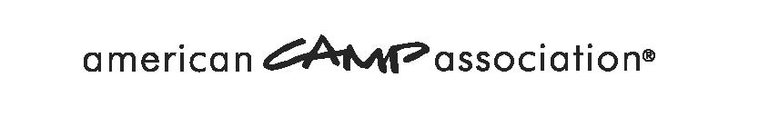
Strategic Planning Meeting Template

9:00 | Welcome and Introductions
9:15 | Understanding the Present Reality: Presentations and Discussions
 | Local Assessment:
 | - What’s going well in the Field Office?
 | - What are our trends: Membership, Participation?
 | - What do our surveys say?
 | National and Regional Assessments:
 | - ACA priorities
 | - ACA support and initiatives
 | - Neighboring Field Office Strengths
Break
10:30 | SWOT Analysis: What is important? Where are the Opportunities?
 | - Strengths: What do we continue because is important to the camp movement?
 | - Weaknesses: What do we stop because it isn’t a priority or do we strengthen it because it is important to the camp movement?
 | - Opportunities: What resources, momentum, access to we have now? Are there partnerships, connections to be taken advantage of?
12:00 | Lunch
1:00 | Status of Volunteerism in the Field Office
1:30 | Prioritize and Determine Goals for 3 years
- What change do we want to see in the field office?
- What can be done?
- What must be done?
2:30 | Action Plan:  Development of Objectives, Tasks with assigned resources, timelines
3:30 | Summary and Next Steps
4:00 | Departure
