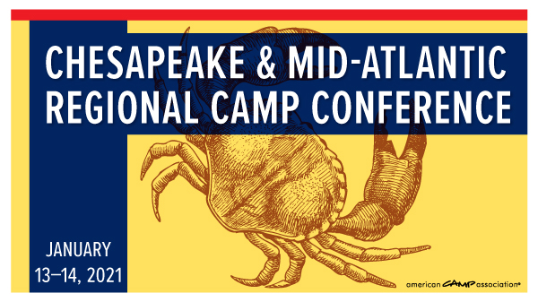

Eligibility
- Applicants must either be a member of ACA or Complete the FREE One Year Member
Each applicant is eligible to receive:
- Funds toward registration fees for the virtual conference – up to 100% of the conference fee.
Application & Awarding timeline:
- Applications will be processed in the order received.

Personal/Contact Information
Name
Camp/ Company Name
- Not Currently Employed

If currently a student, current school Major
Address
City State Zip
Cell Phone Email
Are you an ACA member? YES NO ACA Member #
If no, are you a staff member at an ACA Accredited Camp? YES NO
Camp and Director’s Name Your Position

How much financial aid are you requesting?
______Full Conference Registration OR you are willing and able to contribute $_________.

How did you become aware of this professional development opportunity?

What do you hope to gain by attending this conference/training/opportunity?

Your Signature_____________________________________________ Date________________________

