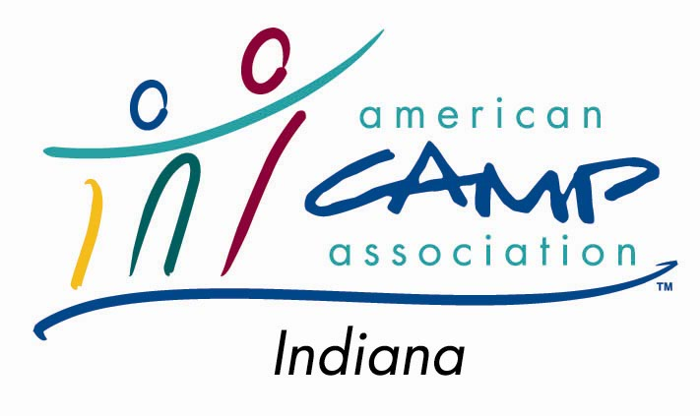 | SCHOLARSHIP REQUEST

Purpose:
To further camp professionalism and create a best practice culture, the ACA Indiana Field Office provides scholarships to Indiana field office members who need financial assistance to participate in professional development opportunities in the areas of camping and youth development.

Guidelines:
- Must be ACA Indiana Field Office member
- Must agree to “share the experience” with other camping professionals (internal audience preferred) through a workshop, presentation or article
- Must show that the experience has direct influence/impact on camping professionalism
- If applicant is unable to attend (except in case of emergency), they are responsible for payment of assistance
- No more than $150 will be granted to each applicant
- Each camp is limited to one scholarship per budget year.

Process:
- Complete the Scholarship Assistance Request form and submit to the Indiana Field Office.
- Requests will be processed for approval by the ACA Indiana Scholarship Committee
- Once approved, candidate will be provided with a Certificate acknowledging the approval and details of payment.
- Once experience is completed, candidate must share the experience and notify the Scholarship Committee indicating when, where and how the experience was shared.

SCHOLARSHIP ASSISTANCE REQUEST

Name: ___________________________________________ Phone: _____________________________________

Address: ________________________________________________________________________________________

Type/Description of experience: ______________________________________________________________________

Location of experience: ____________________________________________________________________________

Date(s) and time(s) of experience: ____________________________________________________________________

Please answer the following questions on a separate page:
Registration

Lodging

Meals

Other

TOTAL

Amount paid by agency
Amount paid by applicant
Amount of request
Amount approved
- Why should the section support your request?
- How will you benefit from the experience?
- How will you share your experience with the section?

I understand that upon approval, I must submit all required paperwork for processing and that if I am unable to attend (except in case of emergency) I shall reimburse the ACA Indiana Field Office for the cost of the scholarship. I also agree, upon approval, to share my experience with other members through a workshop, presentation or article.

Signature : __________________________________________________________

Date: _____________________

Approved by: ________________________________________________________

Approval date: _____________

