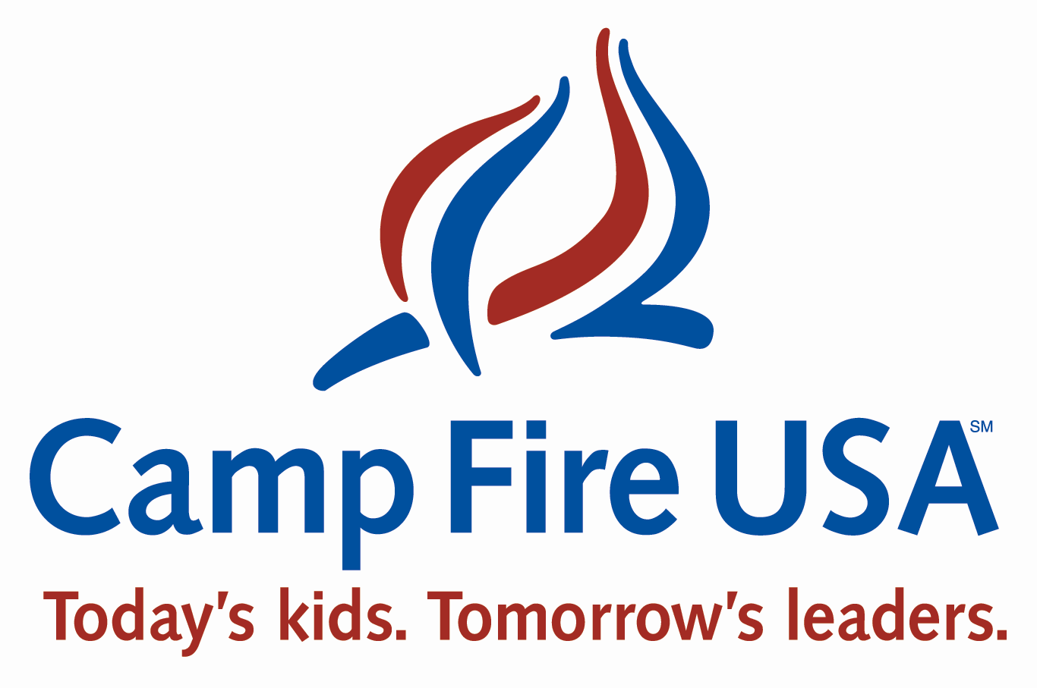

Contact Information

Camp Fire USA Central Ohio Council
Camp Wyandot - ACA #972
Amy Boyd, CEO - ACA #43604
Wes Supper, Camp and Outdoor Education Program Director - ACA # 43856
1890 Northwest Blvd. Suite 240
Columbus, OH 43212
614-481-8227
Amy@centralohiocampfire.org Wes@centralohiocampfire.org

Project Title and Explanation

“Family Nature Clubs”
This project is designed to give families an ongoing opportunity to experience nature with a small group of like minded families. Groups of families consisting of 2 – 10 families will get together on a monthly basis to engage in an outdoor activity. Camp Fire will facilitate these meetings by providing a schedule of outdoor events in the area, specifically at the Columbus and Franklin County Metro Parks, a collaborating partner. We will also conduct outdoor programming at Camp Wyandot. These programs will include programming that is set and established by the Metro Parks, special requests for programming from Metro Parks naturalists and/or other experts based on the interest of the group, and primitive camping and outdoor living skills taught and implemented at Camp Wyandot or other public park. The families will be part of the Camp Fire Club program with a specific interest in outdoor programming and skills. Camp Fire will conduct the marketing for this new program and facilitate the coordination of programs. Each club will establish how often they will meet and may choose from a variety of program offerings throughout the region. Each quarter Camp Fire will offer a program that teaches a specific outdoor skill. The year will culminate in family camp out at Camp Wyandot or at public park of their choice.

The Purpose

The Family Nature Club is a new program idea born out of the Leave No Child Inside national movement. Camp Fire USA Central Ohio Council and the Balcones Council in Austin Texas would like to pilot this program as an additional club model for the Camp Fire system.

It is documented fact that children are suffering from Nature Deficit Disorder as described in Richard Louv’s groundbreaking book, Last Child in the Woods. Louv states “our children are the first generation to be raised without direct contact with natural world”. Researchers Oliver Pergams of the University of Chicago and Patricia Zaradic of the Environmental Leadership Program, Delaware Valley in Bryn Mawr, PA found a steady decline in per capita visits to US National parks since the late 1980’s. They also found that this correlates very strongly with a rise in video-game playing, Internet surfing and movie watching. The researchers call this shift to sedentary, electronic diversions “videophelia,” which according to Pergams, “has been shown to be a cause of obesity, lack of socialization, attention disorders and poor academic performance.”

In the second edition of his book, Louv lists suggestions for transforming our communities to combat this trend. Study after study that shows that “exposure to natural environments improves children's cognitive development by improving their awareness, reasoning and observational skills.” (Pyle 2002). Louv specifically cites Camp Fire USA, Central Ohio Council for launching “Vision 20/10: Reuniting Children and Nature, 10,000 Kids in the Woods by 2010”.

The Family Nature Club is a new, creative program which will get families outside to experience nature together, whether that be in a structured program or just exploring the woods on their own. Families will benefit from being outside in the fresh air, enjoying healthy physical activity, fellowship with other families that share similar interests, learning life-long outdoor skills, and engaging in environmental service projects. Families may have an interest in this type of activity but don’t know where to begin, don’t have the experience or the equipment. Single parent families, especially, may need support in order to successfully learn and engage in outdoor activities. This program answers that need!

Family Nature Clubs are the perfect vehicle to enhance the camp experience. Campers at our Camp Wyandot Resident Camp and Camp Otonwe Day Camp (held at Highbanks Metro Park) learn outdoor cooking skills and/or sleep under the stars at least one night. This is a new experience for many children and they are eager to do it again and to share their new knowledge and skills with their families. They also establish lasting friendships at camp; they would like to have an opportunity to stay connected to each other during the year.
Both campers and their families will benefit. The long term benefits are increased physical and mental health, social skills, academic performance, and strengthening of the family unit. In addition, our natural world will benefit by increasing the number of citizens who value and care for the environment.

We will create a marketing plan for the Family Nature Clubs that targets our resident and day camp families. We will create a blog on our website so that the families can stay connected and let others know about their experience, and we may also be able to get the word out through the Metro Park’s Park Scope magazine. In addition we will also market the Family Nature Clubs to schools throughout the area. This program would become included in our club program mix, which will allow the children and families to progress through Camp Fire’s outdoor skill progression and earn recognition items. This program could be implemented at any camp and we are looking forward to collaborating with the Columbus and Franklin County Metro Parks.

The Budget
The families will pay nominal dues, just as they would for any of our clubs. This grant requests covers the start-up costs for year one, prior to collecting any dues or having a substantial membership base at the beginning.

How will the money be spent?
Lending Post for outdoor gear and supplies (tents, cook gear, sleeping bags etc. for clubs to check out)
$1500

Contracted outdoor specialists (naturalists, primitive skill specialists, etc. at the Metro Parks or at Camp Wyandot)
$800

Promotion (info meetings, brochures, web blasts etc.)
$200

Total program start up = $2500

The timing
We would like to begin the program in the fall of 2009. Therefore we would like to have the money around March of 2009 to begin promotion and acquiring the gear. This initiative is the start of what we hope is a lasting on-going program that will ignite an interest in families camping and exploring the outdoors together.

