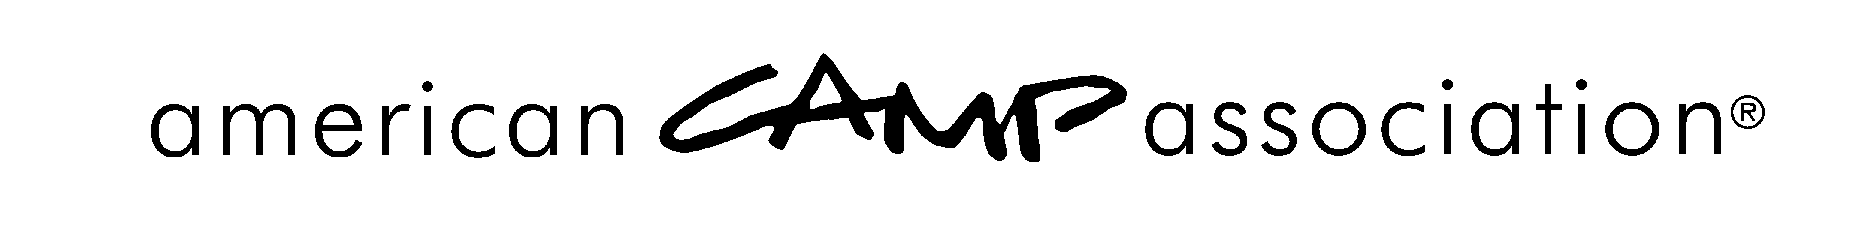
Volunteer Development Committee
Engagement and Support Work Group Roster
2016

Andrea Yenter
Chair, Engagement and Support Work Group
Wisconsin Lions Camp
Rosholt, WI 54473
(B) 715-667-4969
(C) 715-572-8179
ayenter@wisconsinlionscamp.com

Kim Aycock
Camp to Campus Solutions
1406 Ball St.
Galveston, TX 77550
(C) 601-832-6223
kimdaycock@gmail.com

Brian Crater
Camp Ronald McDonald for Good Times
PO Box 35
Mountain Center, CA 92561
(B) 951-659-4609, ext. 10
(C) 951-491-1917
bcrater@campronaldmcdonald.org

Mark Orens
Bar T Ranch
6530 Olney Laytonsville Rd.
Gaithersburg, MD 20882
(B) 301-212-1207
(C) 301-674-3178
morens@bar-t.com

Carla Weiland
Camp Summit
17210 Campbell Rd Suite 180-W
Dallas, TX 75252
(B) 972-484-8900, ext. 105
(C) 972-898-4445
c.weiland@campsummittx.org

Steve Sudduth
Wyonegonic Camps
215 Wyonegonic Rd.
Denmark, ME 04022
(B) 207-452-2051
(C) 207-233-5375
steve@wyonegonic.com

Staff Liaison
Susan E. Yoder
Committee Primary Staff Liaison, and
Engagement and Support Work Group
(B) 800-428-2267, ext. 302
(C) 317-694-2490
syoder@ACAcamps.org

