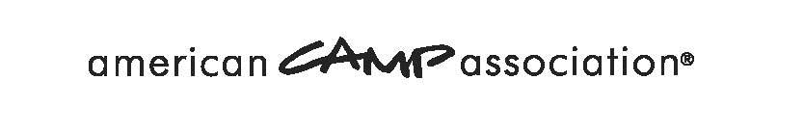
Immediate Corrective Action Notification
of Missed Mandatory Standard(s) Form
The purpose of this notification is to encourage you to immediately bring your camp into compliance with the ACA mandatory standard(s) listed below. Today during the standards visit for camp accreditation, the visitor(s) noted noncompliance with the following mandatory standard(s). (If necessary, list more than one):

Because of the importance of these standards and their identification as mandatory for accreditation, we urge you to immediately take steps to correct this situation. The steps immediately required to comply with each standard listed above are as follows. (If necessary, attach another sheet — make copies per each NCR color.):

Due to our observed noncompliance with a mandatory standard(s), your accreditation status (if previously accredited) has become CONDITIONAL as of the date of this form. The corrective actions noted above must be completed immediately, with documentation postmarked or emailed to the ACA Administrative Office within SEVEN (7) days. This material will be copied and forwarded immediately to your local office and visitor to be evaluated. If effective and remedial steps are taken according to the guidelines above, and if all other accreditation criteria are met, your camp will be eligible for full accreditation, subject to LCOL/Board approval.

Failure to respond to this notice within SEVEN days will result in the automatic removal of accreditation without further notice for camps previously accredited. Camps not responding to this opportunity to document corrective action give up the privilege of published information, unless their requested review is settled in the camp’s favor by October 10 of current year.

Your signature below acknowledges that you have received a copy of this form, you understand that in order to be fully accredited based on this visit you must respond as indicated above, and you understand that reporting the immediate corrective action is required of you within SEVEN days.

Local Office _______________________________________________________________________________________________ Date ________________________________

Camp Name ______________________________________________________________________________________________ Camp # ____________________________

Camp Director’s Signature ____________________________________________________________________________________________________________________

Visitor’s Signature _______________________________________________________________________________________ Visitor # ____________________________

Visitor’s Signature _______________________________________________________________________________________ Visitor # _____________________________

Copies: White — ACA, Yellow — Camp Director, Pink—Visitor

American Camp Association • 5000 State Road 67 North, Martinsville, IN 46151-7902
800.428.2267 • e-mail accreditation@ACAcamps.org • www.ACAcamps.org

