Community and Business Development Chair
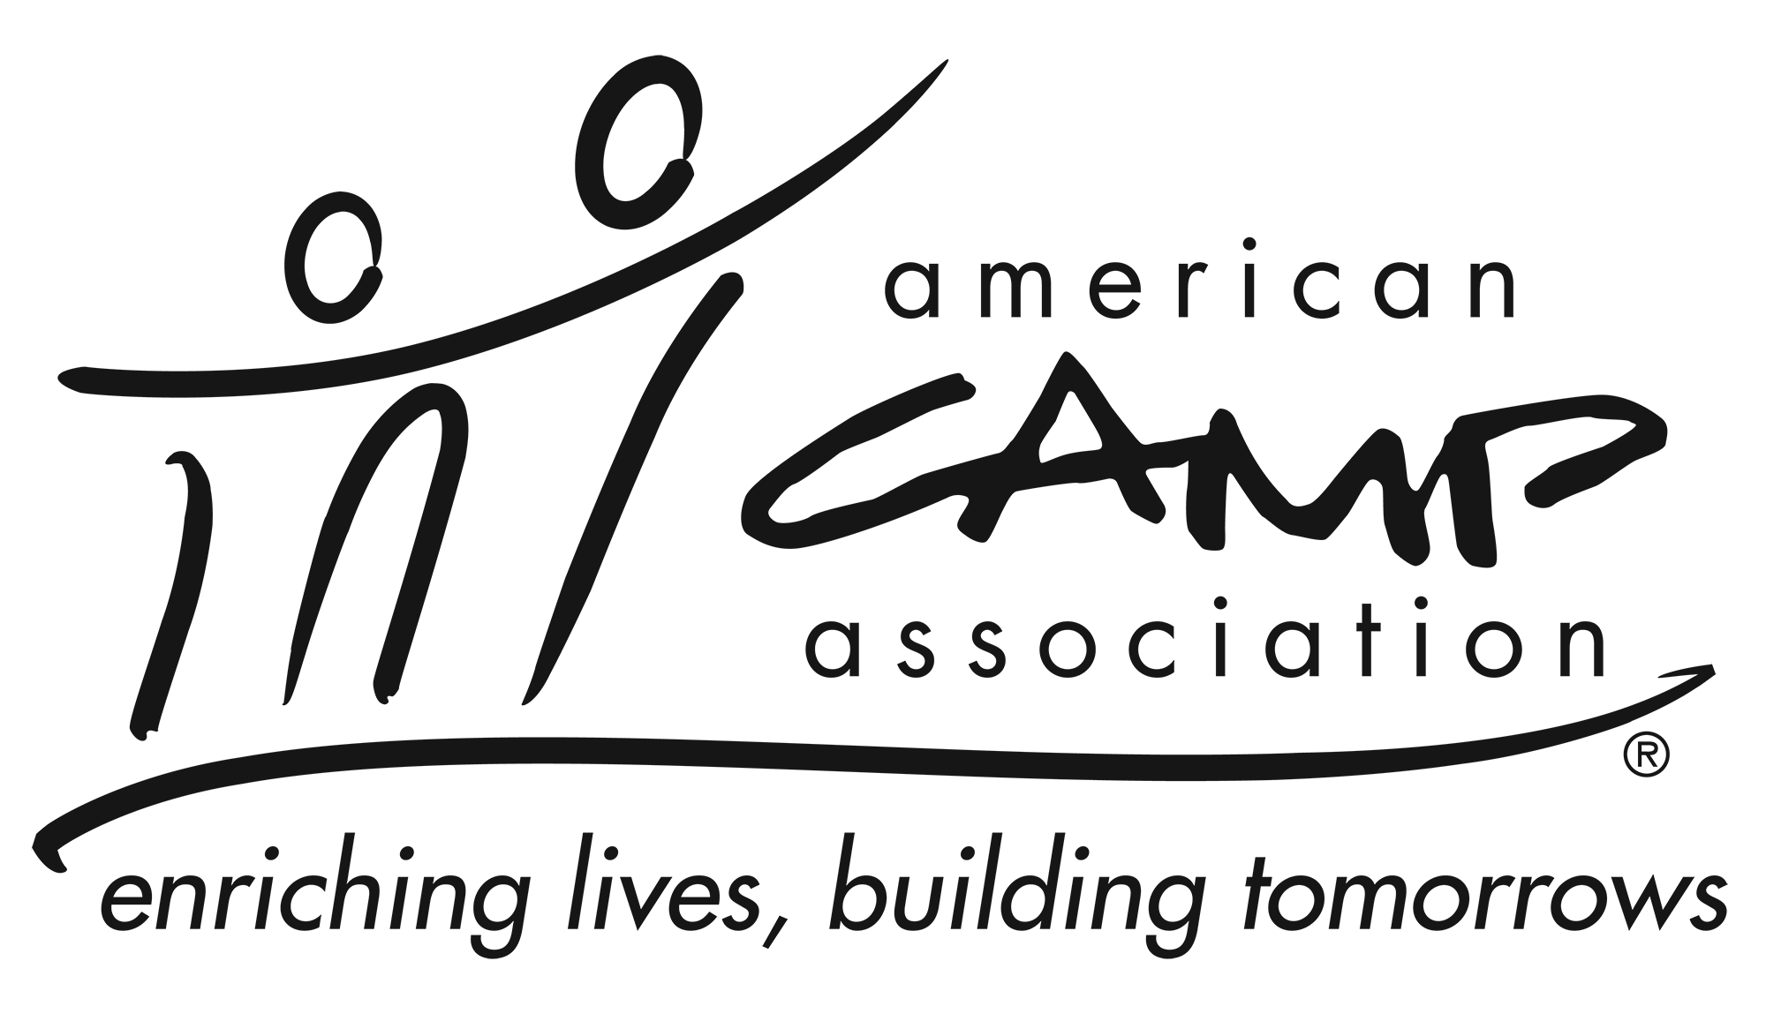

Description
Contribute to the growth of the Association by (a) outreach to and support of current and prospective Business Affiliate members, (b) building community relationships, and (c) communicating the value of the camp experience with individuals and community partners.

Qualifications
- Knowledge of and passion for camp and ACA
- Be an active member of ACA

Experience
- Forming working relationship with organizations and agencies
- Ability to connect with local businesses
- Cultivating strategic relationships

Participation Includes
- Builds rapport and develops alliances with a broad range of people and entities. Leaves others feeling that he/she will be a trusted ally and is careful to act in ways to reinforce that trust over time.
- Work cooperatively with the ACA staff, LCOL and volunteers to develop and implement partnerships and/or working relationships.
- Work with ACA Staff to get business affiliate and event sponsorship and exhibitor leads.
- Work with LCOL to assess the work required service local office members.
- Work with LCOL to define service descriptions.
- Create ad hoc committees, sub groups and task forces as needed.
- Give guidance, stimulation and support to all LCOL members and committees.

Essential Responsibilities
- Proactively searching for opportunities to increase awareness of and support for the value of the camp experience — advancing the cause through outreach and relationship development with numerous constituencies and potential markets.
- Cultivate and recruit Business Affiliates.
- Cultivate and recruit sponsors and/or exhibitors for appropriate events.
- Keep current on information pertaining to: LCOL committees’ initiative efforts and ACA, Inc. growth strategy initiatives.
- Follow all applicable ACA policies and procedures
- Provide updates at Local Council of Leaders meetings
- Attend all LCOL meetings (in person or virtual).

Time Commitment
The Community and Business Development Chair commits to:
- Serve a two-year term.
- Attend LCOL XX in-person and YY Virtual Local Council of Leaders meetings. (if committee meet place the number of meetings required).
- Communicating with ACA Staff and other volunteers in a timely and professional manner.

