Government Relations Chair
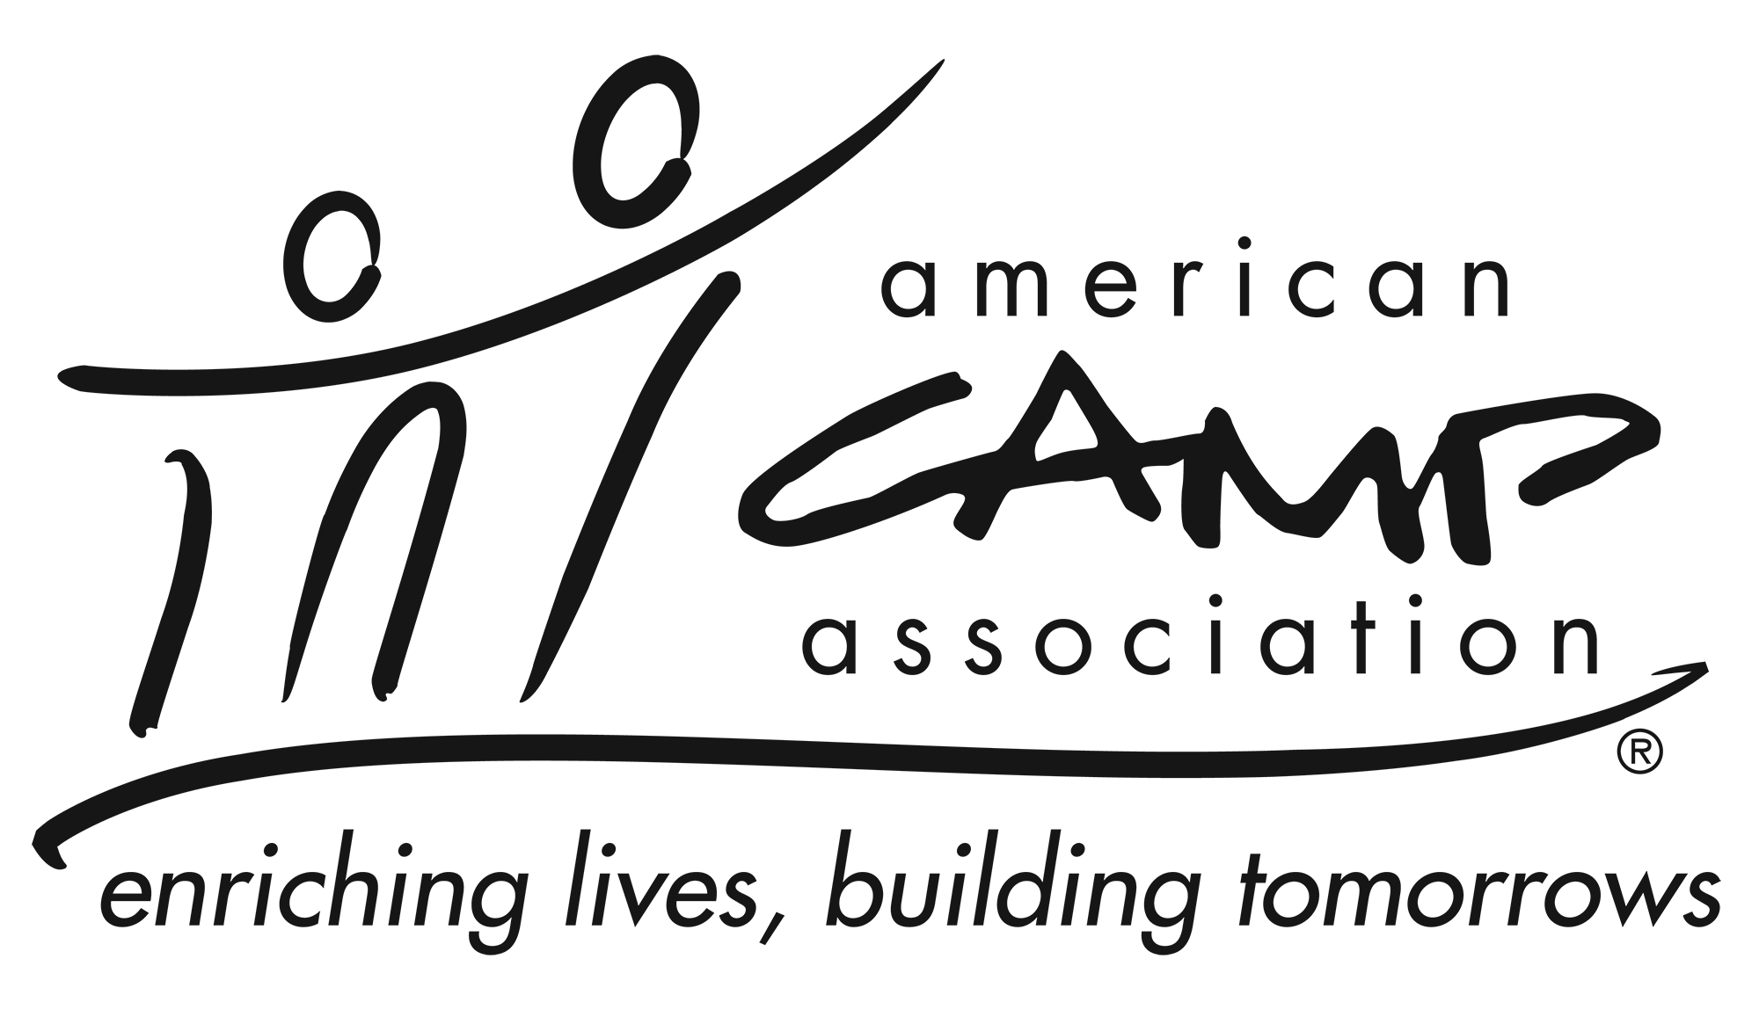

Service Summary
The Local Government Relations Chair provides leadership, support and information to the LCOL and membership related to public policy and government relations. They monitor legislative issues and regulation changes for their area and prepare calls to action as necessary.

Knowledge and Experience
- Ability to lead a team and facilitate work in individuals and groups
- Ability to connect and engage local volunteers
- Experience leading work groups/committees to meet expected outcomes/goals
- Knowledge of the regional “picture” of camp and basic understanding of camp culture(s) within the designated region
- Knowledge and understanding of advocacy work (or willingness to be trained)

Participation Includes
- Work cooperatively with the ACA staff and volunteers to develop and implement government relations strategies
- Organize and facilitate local government relations initiatives, such as invite a local legislator to camp
- Stay informed of emerging issues and trends that affect youth development, the camp profession and industry
- Support and create Voter Voice campaigns, email messages and newsletter articles as needed
- Give guidance, stimulation and support to local volunteers working on government relations initiatives

Essential Responsibilities
- Serve as a local office leader for government relations
- Work with ACA Staff to ensure that local members are informed and educated about issues
- Keep current on information pertaining to: local, state and federal legislative and regulatory issues that may affect camps and youth development programs
- Follow all applicable ACA policies and procedures
- Provide updates at Local Council of Leaders meetings
- Participate in virtual Government Relations Chairs meeting
- Attend LCOL meetings (in person or virtual) each year, (if applicable)

Time Commitment
The Government Relations chair commits to:
- Serve a two-year term.
- Requires a time commitment of 6 to 8 hours per month, on average.
- Attend LCOL meeting XX in-person and YY Virtual Local Council of Leaders meetings. (if applicable).
- Participate in Government Relations Chairs virtual meeting, 3 times per year.
- Communicating with ACA Staff and other volunteers in a timely and professional manner.

