Member-at-Large
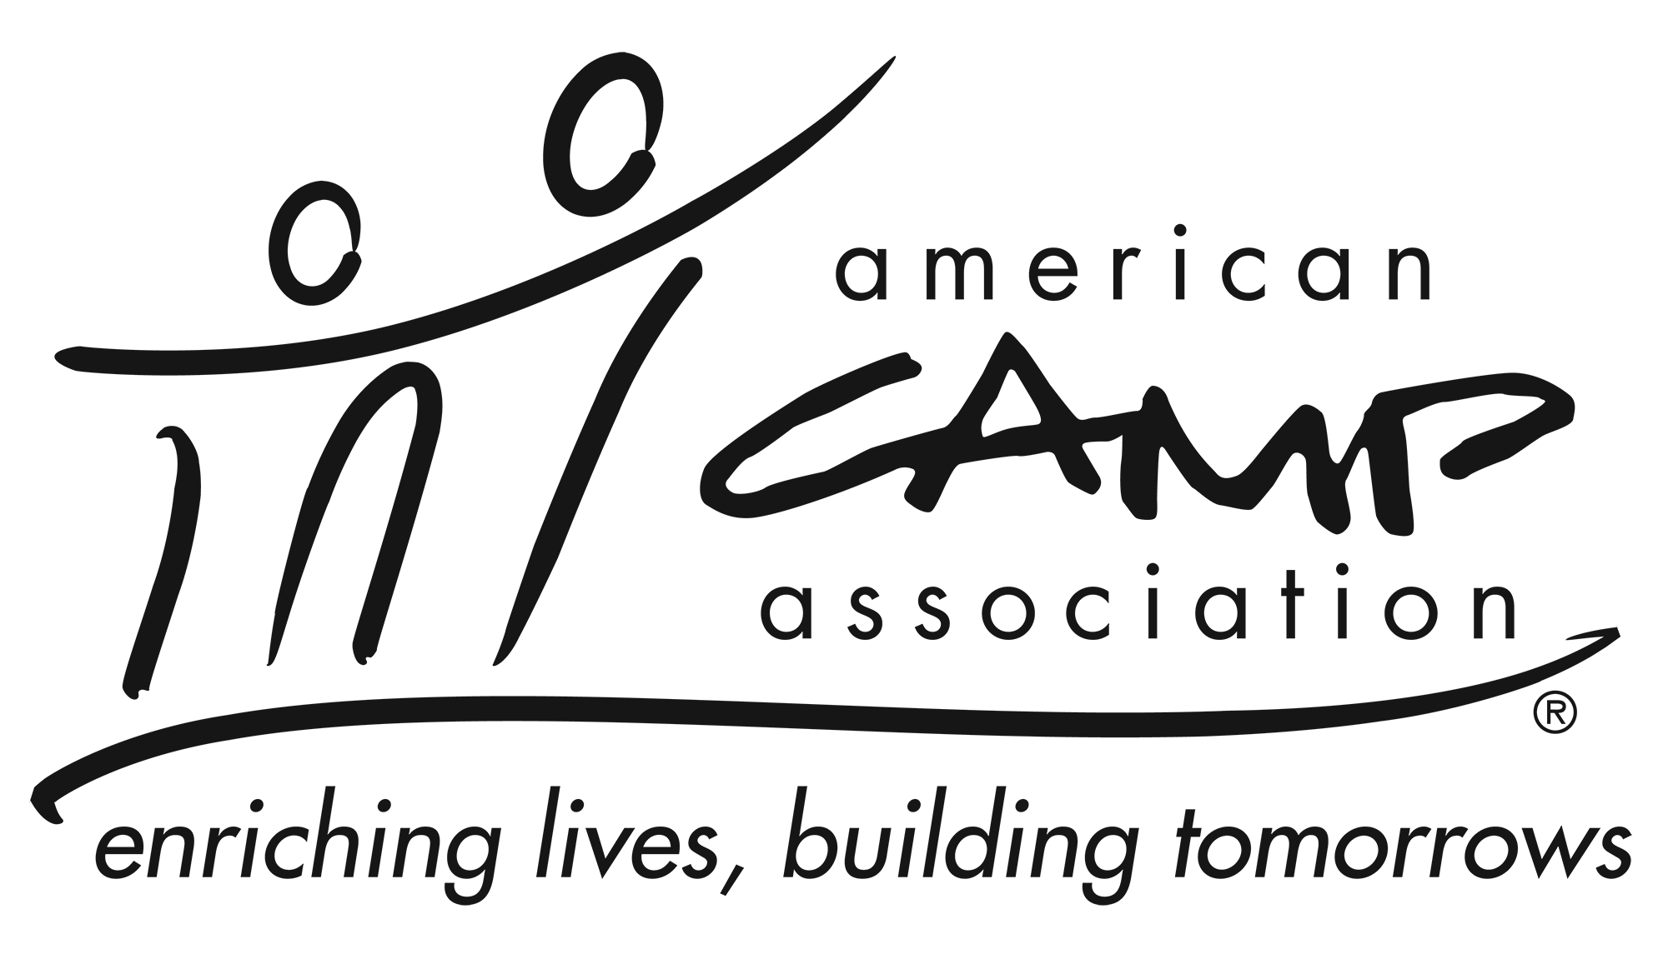

Description
The LCOL Member-at-Large can provide a range of duties, including, but not limited to: serving as an LCOL liaison to affiliate organizations; coordinate with LCOL committees; serve as a state representative

Knowledge and Experience
- Knowledge of and passion for camp and ACA
- Be an active member of ACA

Essential Responsibilities
- Ability to listen, analyze, think clearly and creatively, work well with individuals and groups, balance volunteer tasks with other commitments, manage time, and adhere to deadlines.
- Ability to complete quality projects/initiatives in a timely manner.
- Communicate regularly with the LCOL Chair.
- Contact the LCOL Chair before each meeting to become informed of relevant agenda items.
- Assist in monitoring legislative activity in home state that may impact camps.
- Support educational trainings and conferences.
- Support Standards and Standards Visitors.
- Advocate for camp needs and ACA vision.

Time Commitment
The membership chair commits to:
- Serve at least a two years.
- Requires a time commitment of XX hours per month, on average.
- Attend LCOL XX in-person and YY Virtual Local Council of Leaders meetings.
- Communicate with staff and volunteers in a timely and professional manner.

