Membership Chair
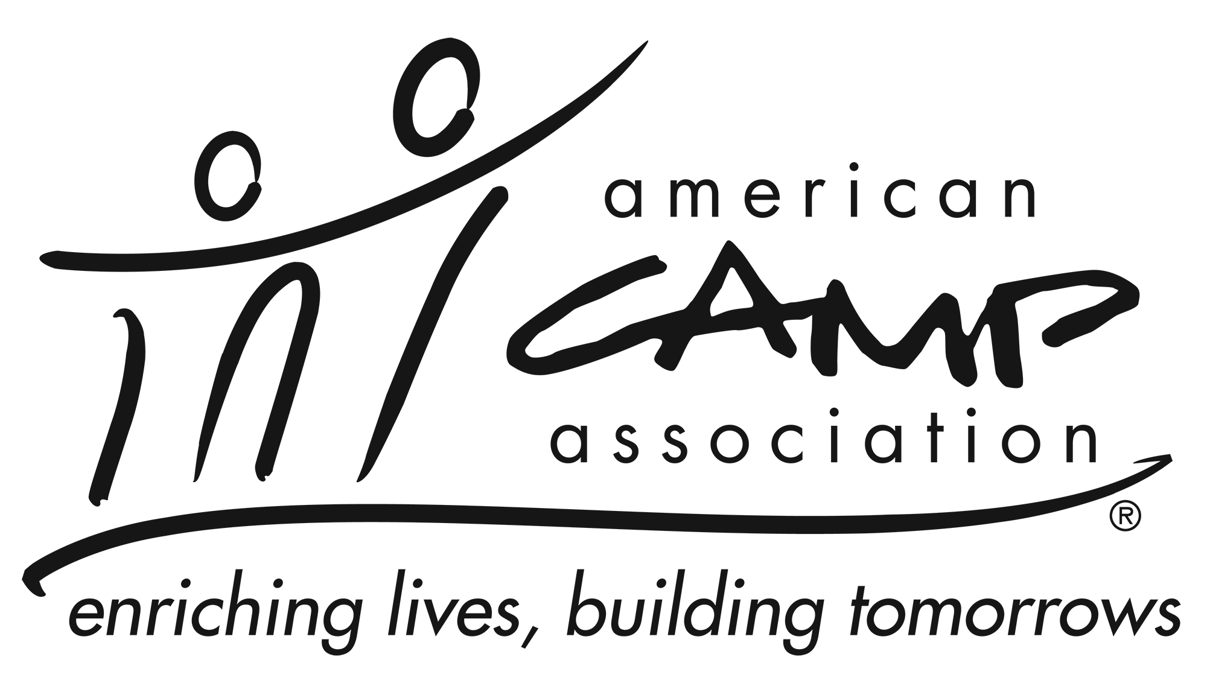

Service Summary
The membership chair works with the membership manager on efforts toward growth and retention of ACA members (i.e., both individual and camp) and customers. In partnership and coordination with membership staff, the membership chair develops and implements member and customer retention strategies in alignment with ACA priorities.

Knowledge and Experience
- Knowledge of and passion for camp and ACA
- Ability to connect with local membership
- Ability to maintain an open line of communication with the membership manager
- Be an active member of ACA

Participation May Include
- Welcoming new camps and professionals.
- Checking in with and providing support to existing camps and professionals.
- Recruiting new camps and professionals.
- Inviting prospects and members to local office events.
- Providing ideas or content for local office newsletter.
- Creating / presenting membership reports at LCOL meetings.
- Helping celebrate successes of camps in local area.
- Helping plan and attend networking events and/or recruitment initiatives.

Essential Responsibilities
- Ability to listen, analyze, think clearly and creatively, work well with individuals and groups, balance volunteer tasks with other commitments, manage time, and adhere to deadlines.
- Willingness to prepare for and attend LCOL and membership meetings
- Ability to complete quality projects/initiatives in a timely manner.
- Cultivate and recruit potential future membership volunteers.
- Possess honesty, be sensitive to and have tolerance of differing views, be friendly, have a responsive and patient approach, have community-building skills, possess personal integrity, and possess a dedication to ACA.

Time Commitment
The membership chair commits to:
- Serve at least a two years.
- Requires a time commitment of XX hours per month, on average.
- Attend LCOL XX in-person and YY Virtual Local Council of Leaders meetings.
- Coordinate and attend 2 to 4 committee meetings (in person or virtual) each year.
- Communicate with membership staff and volunteers in a timely and professional manner.

