Membership Committee Member
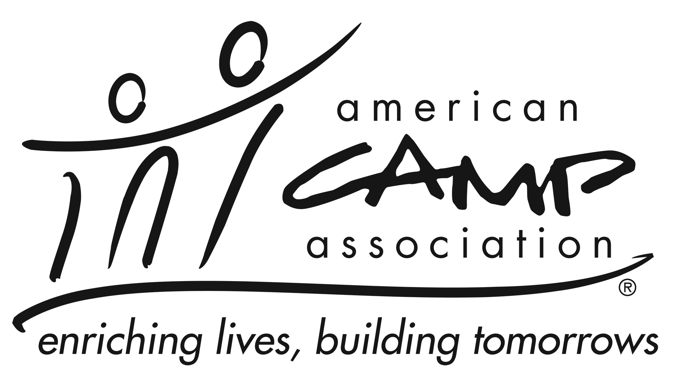

Service Summary
Membership committee member works with the membership chair, manager, and committee members to plan and implement specific ACA efforts and events that support retention and developing new members. Committee members focus on growth and retention of ACA members (i.e., both individual and camp) and customers.

Knowledge and Experience
- Knowledge of and passion for camp and ACA
- Ability to connect with local membership
- Ability to maintain an open line of communication with the membership manager
- Be an active member of ACA

Participation May Include
- Welcoming new camps and professionals.
- Checking in with and providing support to existing camps and professionals.
- Recruiting new camps and professionals.
- Inviting prospects and members to local office events.
- Collaborating on marketing efforts for local office events.

Essential Responsibilities
- Ability to listen, analyze, think clearly and creatively, work well with individuals and groups, balance volunteer tasks with other commitments, manage time, and adhere to deadlines.
- Willingness to prepare for and attend committee and other relevant meetings
- Ability to complete quality projects and initiatives in a timely manner.
- Possess honesty, be sensitive to and have tolerance of differing views, be friendly, have a responsive and patient approach, have community-building skills, possess personal integrity, and possess a dedication to ACA.
- Cultivate and recruit potential future membership volunteers.

Time Commitment
The membership committee member commits to:
- Serve at least one year.
- Requires a time commitment of 2 to 4 hours per month, on average.
- Attend 2 to 4 membership committee meetings (in-person or virtual) each year.
- Communicate with membership chair and staff in a timely and professional manner.

