Standards Chair
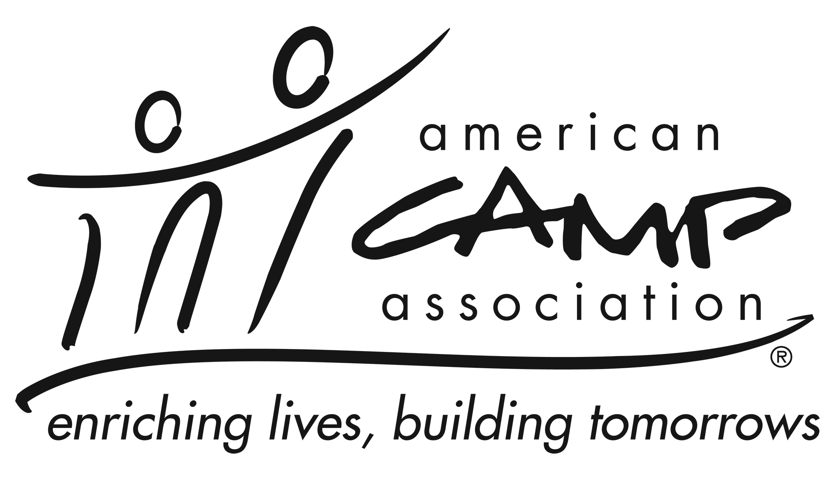

Service Summary and Required Tasks
The Standards Chair works in close partnership with the Standards Manager and directs the local Standards Committee to implement training, schedule visitors and visits, handle reviews, submit reports and maintain records, coordinate mentoring for camps, and assist with complaints involving standards. This document provides an overview of the Standards Chair’s responsibility. Please contact the staff member who supports standards for a full job description.

Knowledge and Experience
- Be a current ACA member
- Have served as a visitor for at least three years
- Preferably, have served at least one year as member of the local Standards Committee
- Preferably, be an ACA Standards Instructor, or be willing to become one
- Have knowledge and understanding of the ACA standards and their value to the camping profession and the role of the accreditation program within ACA

Participation Includes
- Assign trained visitors to complete the local office’s accreditation visits
- Complete and submit reports that document Standards Committee and LCOL actions
- Required Training: Attend national leadership training when offered, every 2-4 years. When a standards chair begins the role in a year when in-person training is not offered, web-based training is provided.

Essential Responsibilities
Work with a local Standards Committee and Standards Manager to:
- Coordinate a) standards committee meetings, b) visits and visitors for camps expecting accreditation visits, c) training for camps and visitors, and d) local reviews
- Prepare and submit reports requiring Standards Committee or LCOL action, meeting national deadlines as applicable
- Provide updates at LCOL meetings
- Plan courses to meet training needs of the local area
- Work with the standards committee to provide mentoring for new camps and directors

Time Commitment
The Standards chair commits to:
- Serve a three-year term. (actual term duration TBD)
- Attend LCOL XX in-person and YY Virtual Local Council of Leaders meetings. (if committee meet place the number of meetings required).
- Coordinate and attend standards committee meetings, in person or virtually, 1-3 times per year.
- Communicate with staff and volunteers in a timely and professional manner.

