Volunteer Engagement and Development Chair
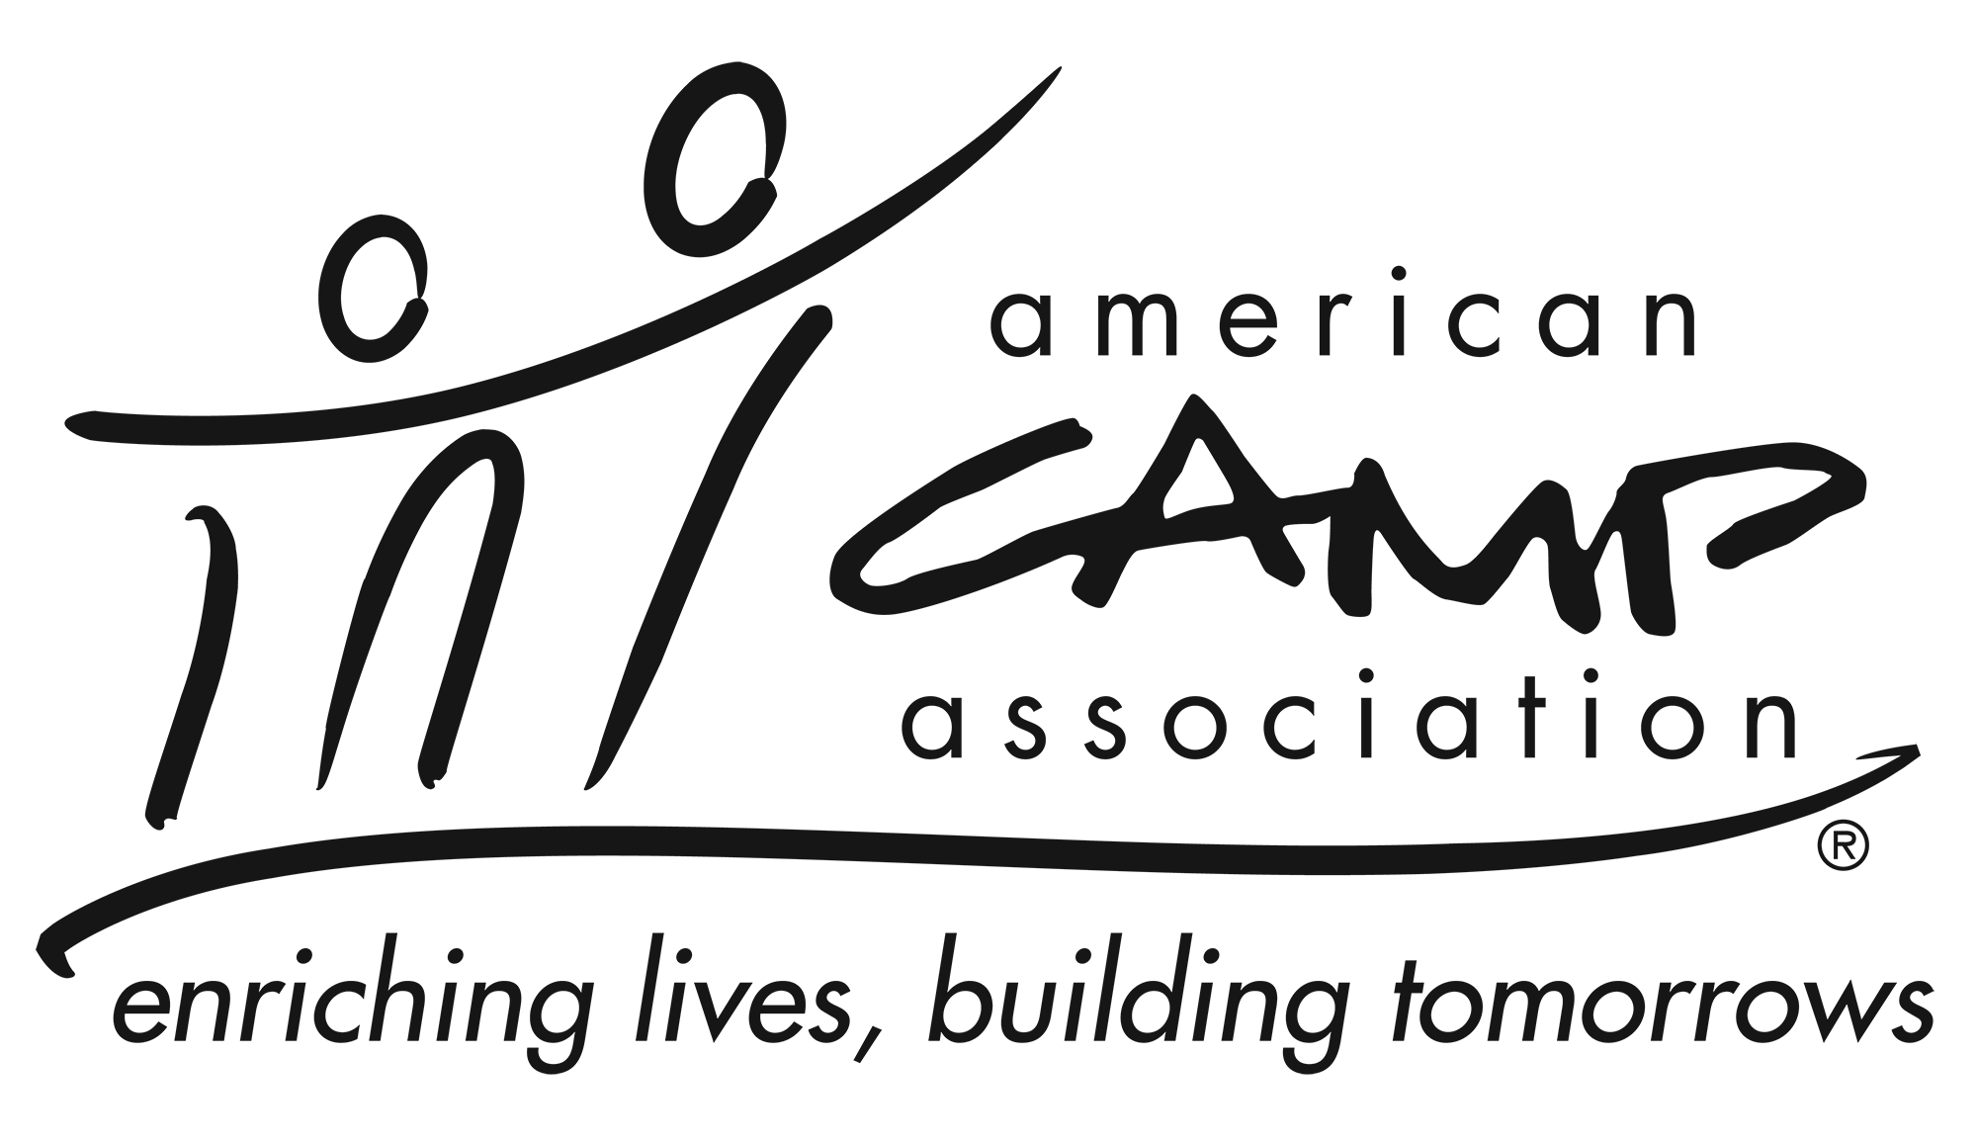

Description
The Volunteer Engagement and Development Chair works Local Council of Leaders and regional staff to lead and organize volunteer development system including: cultivation, recruitment, training, support and recognition to ensure delivery of local services.

Qualifications
- Knowledge of and passion for camp and ACA
- Be an active member of ACA

Experience
- Identifying volunteer opportunity areas
- Matching potential volunteers to opportunities
- Providing orientation and training to volunteers

Participation Includes
- Work cooperatively with the ACA staff, LCOL and volunteers to develop and implement volunteer development.
- Work with LCOL to assess the work required service local office members.
- Work with LCOL to define service descriptions.
- Create ad hoc committees, sub groups and task forces as needed.
- Give guidance, stimulation and support to all LCOL members and committees.

Essential Responsibilities
- Serve as chief volunteer developer: articulating the values and communicating the benefits volunteering ACA, (Insert, Local Office).
- Work with ACA Staff and volunteers to analyze objectives and key results volunteer development efforts.
- Keep current on information pertaining to: LCOL committees’ initiative efforts and ACA, Inc. growth strategy initiatives.
- Follow all applicable ACA policies and procedures
- Provide updates at Local Council of Leaders meetings
- Attend all LCOL meetings (in person or virtual).

Time Commitment
The volunteer engagement and development chair commits to:
- Serve a two-year term.
- Attend LCOL XX in-person and YY Virtual Local Council of Leaders meetings. (if committee meet place the number of meetings required).
- Communicating with ACA Staff and other volunteers in a timely and professional manner.

