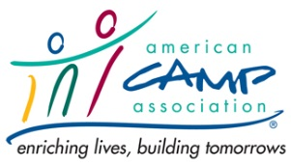
ACA Local Office Communications
Bi-Weekly Newsletter - 2018

Form should be submitted by Tuesday of the Friday newsletter sending date.
1/5, 1/19, 2/2, 2/16, 3/2, 3/16, 3/30, 4/13, 4/27, 5/11, 5/25, 6/8, 6/22, 7/6, 7/20, 8/3, 8/17, 8/31, 9/14, 9/28, 10/12, 10/26, 11/9, 11/23, 12/7, 12/21
Volunteer Making Request
Name and Email:
Supporting Staff Member:
Event:
Date of Newsletter:

Image:
(Be sure the image is open-source and/or we have the rights to post and use.)

Newsletter Body:
Please keep this information, short, informative and refer readers to the expanded information on ACA’s website. Include links were appropriate and format as you would like it to appear (i.e. bullets, indents, ALL CAPS, etc.).

