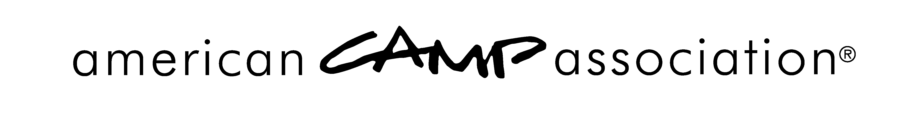
EVALUATIONS

Course Evaluations
Participants in all courses — Basic Standards Course, Standards Update Course, Visitor Update Course, or Associate Visitor Course — are encouraged to evaluate the course. They should be provided a link to the evaluation form. An updated link will be provided each fall, so that responses can be analyzed over time. For courses to prepare for 2016 visits, occurring fall 2015 or after, use this link: www.surveymonkey.com/r/StandardsTrainingEval2016

Visit Evaluations by the Camp
Camps who have had accreditation visits are allowed and encouraged to evaluate the process. They should be provided with a link to an evaluation form. An updated link will be provided each spring, so that responses can be analyzed over time. For 2016 visits, use this link: www.surveymonkey.com/r/ACACampVisit2016

Visit Evaluation by the Visitor
Visitors who have conducted accreditation visits are encouraged to evaluate the process. They should be provided a link to the evaluation form. An updated link will be provided each spring, so that responses can be analyzed over time. For 2016 visits, use this link: www.surveymonkey.com/r/ACAVisitor2016

