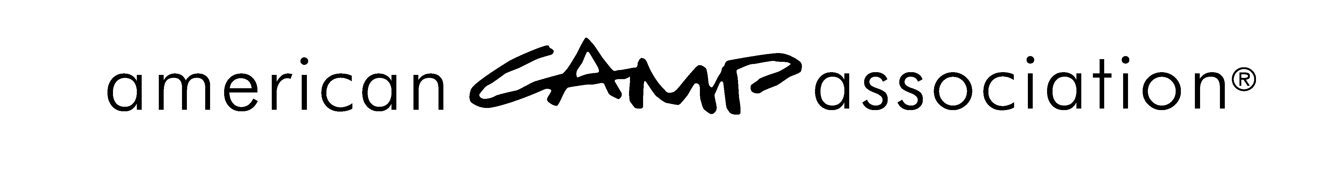

COURTESY STANDARDS VISITATION REQUEST FORM

This form should be used or the same information relayed via e-mail.
Courtesy Standards Visitation Request |  |  |  |  | Date:
To: |  |  | Office: ACA,
From: |  |  | Office: ACA,
THIS IS AN OFFICIAL REQUEST FOR THE CONDUCT OF A VISIT
Camp # | Camp Name:
Camp Location:

ACA Primary Contact Name: |  |  |  | Member #
Phone: |  | Email:
Enclosed: Visitation Profile Camp info sheet
Camp brochure Other:___________________ __________
SEND PERTINENT CORRESPONDENCE AND INFORMATION TO
Name: |  |  | Phone:
Address:

Email:

It is our understanding that a bill for visitation expenses for mileage, meals, lodging, and general charges (if any) will be submitted and paid for by the “home” area. We further understand that the camp self-assessment will be conducted in the requesting area/office, and a copy will be forwarded to the visiting office.
 - - - - - - - - - - - - - - - - - - - - - - - - - - - - - - - - - - - - - - - - - - - - - - - - - - - - - - - - - - - - - - - - - -
Please indicate whether you accept or decline, then detach and return to office initiating request

ACCEPTANCE
ACA, _ _ agrees to visit Camp _and to forward any pertinent correspondence to the office where membership is held.
Signed: |  |  |  | Date:
Phone: | Email:
Visitors assigned:
Name: |  | Phone:
Email:
Name: |  | Phone:
Email:
DECLINATION
ACA, declines visitation to Camp .
Rationale:
Signed: |  |  |  | Date:
Phone: |  |  | Email:

