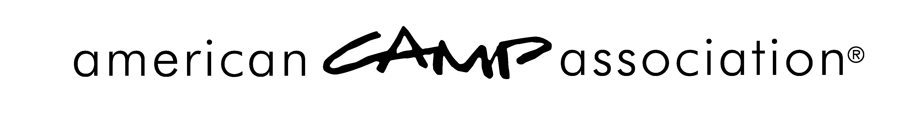

Notification of Failure — Notification to Camp from Local Office — SAMPLE

<DATE>

<CAMP NAME AND ADDRESS>

RE: <CAMP NAME> <Camp #>

Dear <PRIMARY CONTACT OF CAMP>,

On <DATE OF LCOL OR BAORD MEETING>, the <Local Council of Leaders or Affiliate Board of Directors>, met to determine the accreditation status of each camp in our area. As you should be aware, «Camp Name» did not meet the required minimum score to obtain accreditation this year. And, while accreditation was not obtained this year, we are confident that you can gain accreditation and are anxious to help you prepare for another visit next year. Please let us know how we can assist you. Your percent scores are as follows:
Site and Food Service | <88%>
Transportation | <88%>
Health and Wellness | <97%>
Operational Management | <100%>
Human Resources | <84%>
Program Design and Activities | <85%>
Program Aquatics | <87%>
Program Trip and Travel | <54%>

Mandatories missed and corrected:
<PT.5.2> | <PA.4.1> | <PA.17.1> | <PA.21.1> | <PA.31.1>

Your camp's accreditation status is effective immediately. Your scores are kept confidential to you, to ACA, Inc., and the Local Standards Committee. They are not shared with the public because of the danger of misinterpretation.

Because your camp is not accredited, you may not use the ACA logos or statements indicating that accreditation has been achieved or applied for. If your camp was accredited in the past, the ACA Accredited Camp® logo must be removed from all electronic and printed materials.

Thank you for your cooperation! We look forward to working with you.

Yours truly,
<Name>,
ACA, <Local Office Name> Local Council of Leaders Chair
American Camp Association
5000 State Road 67 North, Martinsville, IN 46151-7902 • 765.342.8456 • 765.342.2065 fax • www.ACAcamps.org

