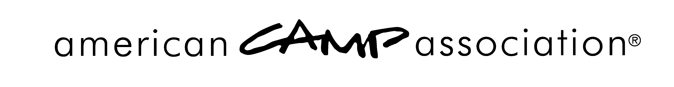

LOCAL OFFICE REPORT OF REVIEW

Report of Review
Camp Name: |  |  | ACA number:
Visitors
Name: |  | Phone:
Name: |  | Phone:
Name: |  | Phone:
Hearing
Date of Hearing: | Date of LCOL/Board Meeting:
Camp Representative(s) at Hearing:

Local Representatives at Hearing:

Action of LCOL/Board (more than one may be marked)
Voted to Accredit
Voted to not Accredit*
Voted to forward Review of Accreditation to National Standards Commission as an Appeal *
Other (specify):

Standards Chair Signature: |  |  |  | Date:
*If the LCOL/Board has voted to NOT accredit or voted to forward the Review to the NSC as an Appeal, all documentation related to the review should be sent immediately to the Director of Standards at the ACA, Inc. office in Indiana. Included should be all actions of the LCOL/Board, all recommendations from the local leadership to the NSC, and rationale for the actions and recommendation.

PLEASE USE THE FORM ON THE REVERSE SIDE TO SUMMARIZE THE ACTIONS AND RECOMMENDATIONS OF THE local leadership.

Return this Form with local Score Report by October 15.

SUMMARY

Local Office Action and Recommendations of Review

Summary of decisions of Local Standards Committee on each standard or area.
(Submit extra pages if necessary.)
Standard # | Action | Rationale
Summarize action of LCOL/Board and give rationale:

Recommendations (if any) to the National Standards Commission:

Significant minority positions or other information:

