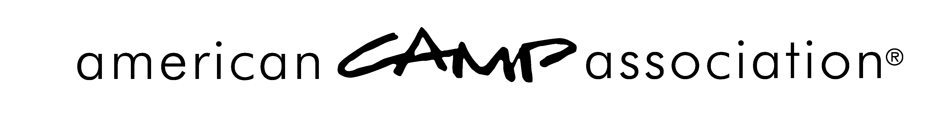

Denial of Accreditation Notification — SAMPLE, Sent by ACA, Inc.

<DATE>

<CAMP NAME AND ADDRESS>

RE: <CAMP NAME> <Camp #>

Dear <PRIMARY CONTACT OF CAMP>,

Your camp, <Camp Name> was trying to become accredited by the American Camp Association® and was visited this year. Standards policies and public expectation specify that ACA-Accredited camps must comply with and adhere to all applicable mandatory standards for accreditation.

Noncompliance and failure to correct the missed mandatory standards from the Immediate Corrective Action Notices from your visit on <Insert date> within the stipulated seven-day time frame has resulted in immediate denial of accreditation to <Camp Name>.

We hope you recognize our obligation to preserve the integrity of our national accreditation program and maintain the public trust. Accreditation is truly a mark of distinction, and we are as eager as you to have you achieve that distinction again. In the meantime, until such time as <Camp Name> has been revisited and found to be in compliance with the ACA accreditation criteria, you are ineligible to use the ACA logos or to imply accreditation by the American Camp Association.

Please contact us if you believe the information related to this issue is inaccurate or requires review through your local office.

Sincerely,

American Camp Association
Director of Accreditation

cc: Standards Chairperson(s)
ACA Standards Specialist

American Camp Association
5000 State Road 67 North, Martinsville, IN 46151-7902 • 765.342.8456 • 765.342.2065 fax • www.ACAcamps.org

