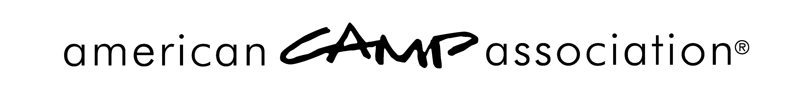

Removal of Accreditation Notification — SAMPLE, Sent by ACA, Inc.

<DATE>

<CAMP NAME AND ADDRESS>

RE: <CAMP NAME> <Camp #>

Dear <PRIMARY CONTACT OF CAMP

Your camp, <Camp Name> has been accredited by the American Camp Association® and was visited this year. Standards policies and public expectation specify that camps must comply with and adhere to all applicable mandatory standards for accreditation.

Noncompliance with a mandatory standard(s), caused your accreditation status to become conditional, as of <INSERT DATE>, the date of your visit. Furthermore, because of your failure to correct the missed mandatory standard from the Immediate Corrective Action Notice within the stipulated seven-day time frame, removal of accreditation is required.

We know you recognize ACA’s obligation to preserve the integrity of our national accreditation program and maintain the public trust. Accreditation is truly a mark of distinction and we are as eager as you to have you achieve that distinction again. In the meantime, until <CAMP NAME> has been revisited and found to be in compliance with the ACA accreditation criteria, you are ineligible to use the ACA logos or to imply accreditation by the American Camp Association.

Please contact us if you believe the information related to this issue is inaccurate or in review through your local office.

Sincerely,

American Camp Association
Director of Accreditation

Attachments/Enclosures
cc: Standards Chairperson(s)
American Camp Association
5000 State Road 67 North, Martinsville, IN 46151-7902 • 765.342.8456 • 765.342.2065 fax • www.ACAcamps.org

