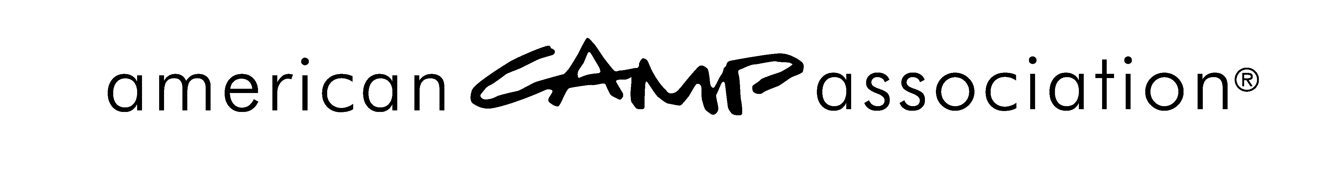

Standards Planning Calendar
Standards Year Is November 1 – October 31

September (transition month – feet in two different years)
Review local area score reports
Follow-up on ICAs, failures, and reviews
Schedule and complete local area reviews
Complete final score report
Follow-up on missing Statements of Compliance
Review preliminary report of camps to be visited next summer (ongoing)
Schedule standards courses in local area
Recruit candidates for Associate Visitor Course
Recruit candidates for Instructor Training
October (transition month – feet in two different years)
LCOL/Board approval of final score report
LCOL report of the actions taken must be filed with the ACA administrative office before October 15
Camps receive notification of accreditation in writing by November 1.
Support standards related courses in local area
Camps are notified of visit due and training requirements
Follow-up on new camps (ongoing)
November
Notify visitors to update info
Remind visitors of training requirements
Follow-up on missing Statements of Compliance
Gather list of visitors willing to serve as reviewers for Annual Accreditation Report (AAR)
December
Support standards related courses in local area
Share information specific to completion of Annual Accreditation Report (AAR)
Assign visitor reviewers for AAR
January
Support standards related courses in local area
Review list of camps to be visited (ongoing)
Review Standards Visitors Report
Follow-up on Camp Information Forms due February 1 (or date specified by local area)
Assign visitor reviewers for AAR

February
Support standards related courses in local area
Review list of camps to be visited (ongoing)
Review Standards Visitors Report
Follow up on Camp Information Forms not yet received
Attend standards events at ACA National Conference

Begin assignments of visitors to camp visits
Visitor Information Forms and letter sent by March 15
Final reminder for camps to complete AAR (due by February 1)
Follow-up with visitor/reviewers of AAR
March
New camps have until March 1 to apply for accreditation
Support standards courses in local area
Camp Visit Information Forms and letter sent by March 15
Follow-up on new camps
April
Follow-up on visitor assignments and camp visits
LCOL/Board action on any requests for extension

May
Follow up on visitor assignments and camp visits
Written Documentation Review information to be submitted/ by May 1 with documents reviewed within 2 weeks (or scheduled to be completed by start of the summer staff training)
June
Follow up on visitor assignments and camp visits
Follow up on ICA’s, Failures and Reviews
July
Follow up on visitor assignments and camp visits
Follow up on ICA’s, Failures and Reviews
August
Review Local Area Score Reports
Follow up on ICA’s, Failures and Reviews
Review score reports for accuracy, missing camps, etc.

