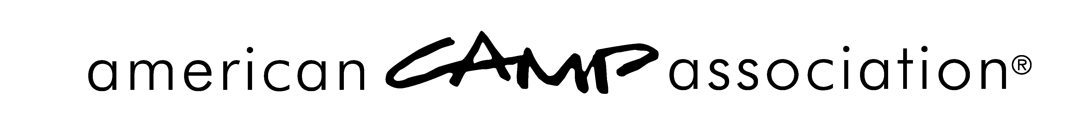

RELEASE of LIABILITY

TO BE READ AND SIGNED BY EACH PERSON BEFORE PARTICIPATING IN ANY ACTIVITY-BASED ACA COURSES.

I have requested that the American Camp Association (ACA) <<Local Office/Affiliate Name>> to enroll me as a participant or instructor in an activity-based course sponsored by them as part of <<course name>>. As a condition of receiving this benefit, I, the undersigned, do hereby agree to the following:

I understand that my presence at, and participation in, this continuing education course can expose me to dangers both from known risk and unanticipated risk. Acknowledging that such risks exists, I, and by signature my heirs, hereby release and discharge the ACA, Inc. and ACA <<Local Office/Affiliate Name>> and its officers, agents, and employees from any and all claims or liability for personal injury or property damage I may suffer while attending this course, including, but not limited to, any claim arising out of any condition of the premises at which the course is held or the conduct of any person in connection with the preparation for, supervision of, or conduct of any activity, whether planned or unplanned, in connection with the course. I specifically agree to release and hereby release ACA, Inc. and ACA <<Local Office/Affiliate Name>> and the officers, agents, and employees of them for any negligence of either or the officers, agents, or employees of both. I understand that participation in this activity is strictly voluntary and I freely choose to engage in this activity.

READ THIS! YOUR LEGAL RIGHTS ARE AFFECTED.

Signature Date Signed
Name (printed) Location of Event
Address Date of Event

