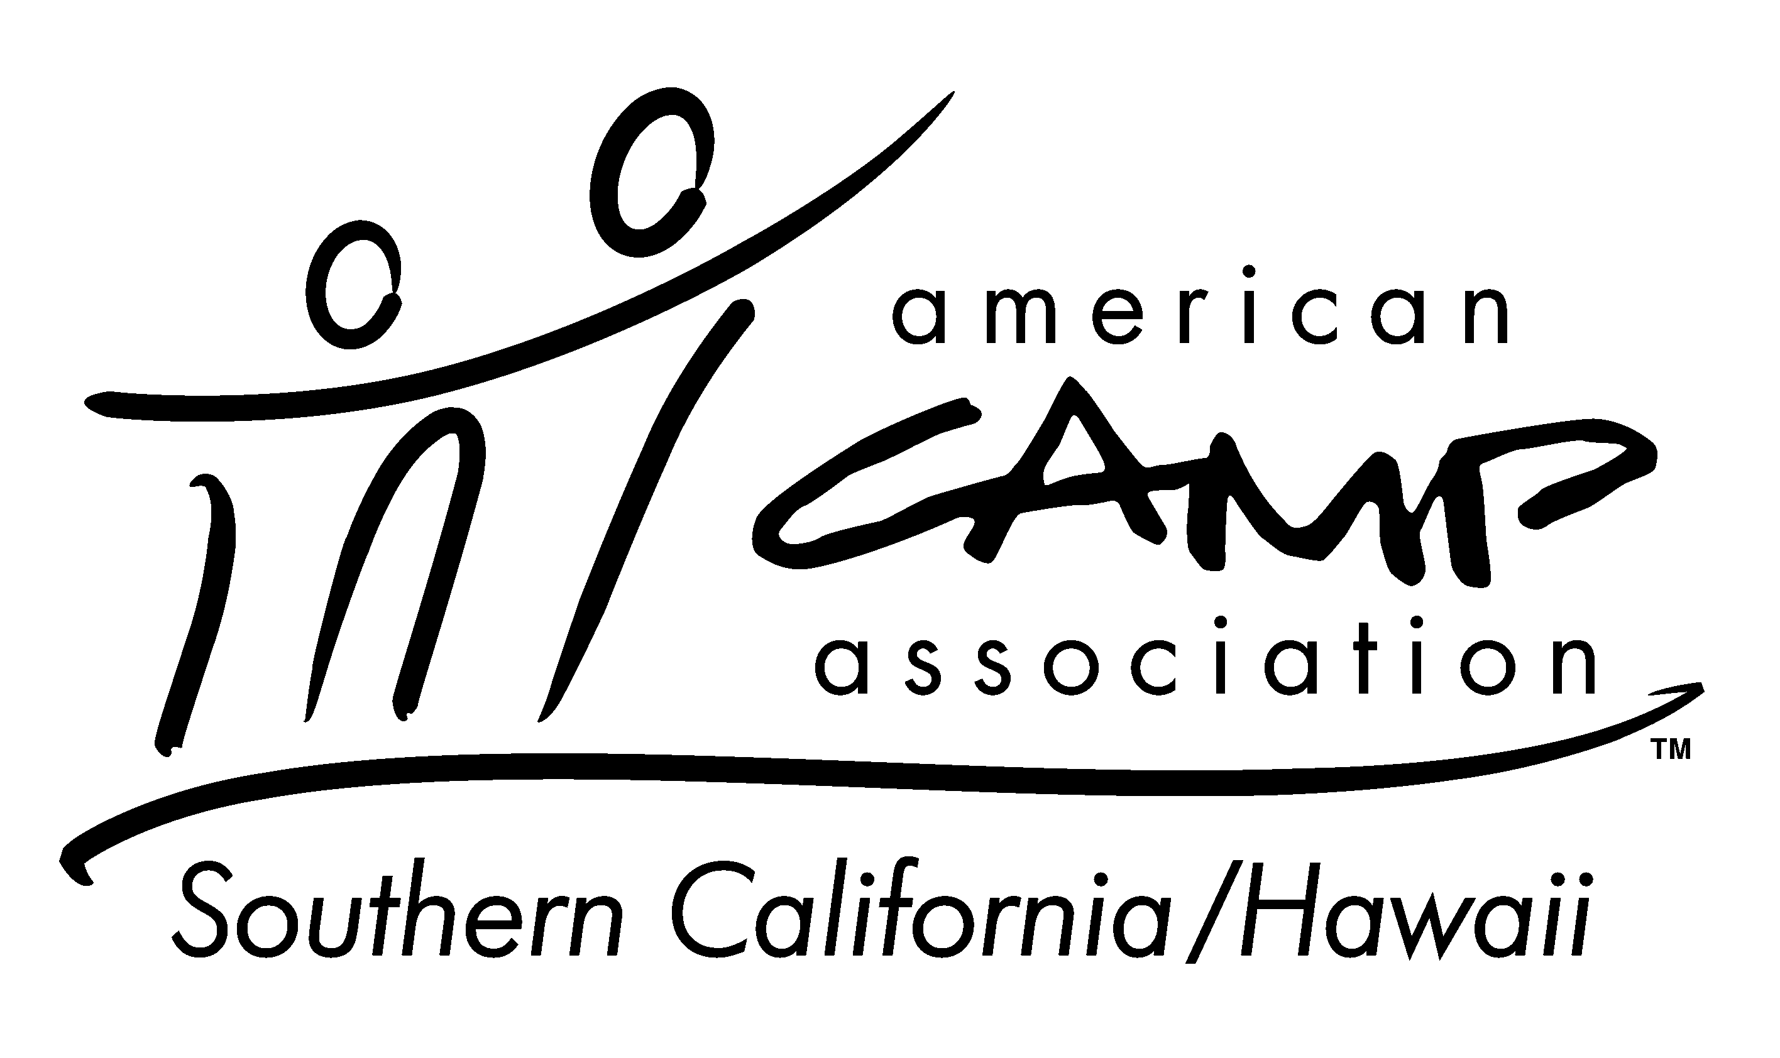
New Director Orientation (your logo here ->)
Pre-Course Questions

To help our facilitators better prepare for your course and understand the type of camp program you are representing, please complete this short form and email it back to: (insert event coordinator/local staff person and email) prior to your course. Thank you!

Your Name | Name of Camp
Position at Camp | Location of Camp

Description of your camp program, affiliation, camper population (please check all that apply):
- Day Camp
- Resident Camp (sleep-away camp)
- My camp is operated by a Parks & Rec (either city or county)
- My camp is operated by an agency (Boy Scouts, Girl Scouts, YMCA, Boys & Girls Club, etc)
- My camp is operated by a business (health club, gym, etc)
- My camp is operated for profit by private individuals/owners
- My camp is operated by a private not for profit organization (Cancer Society, etc)
- My camp is operated by a religiously affiliated organization.
- My camp primarily serves campers with special needs
- My camp serves pre-school age children (3-5 years old)
- My camp serves elementary/middle school age children (6-12 years old)
- My camp serves teens (13-18 years old)
Please share your primary role at the camp:
- I am a full-time, year-round camp director
- I am the camp director or program director during the summer, but also work for the organization in another or similar capacity during the rest of the year.
- I am a part-time, year-round camp director
- I am a seasonal camp director hired to run the camp for the season
- I am a seasonal assistant director, program director or supervisor at the camp.
- My position is not described, I am _________________________(volunteer, support staff)
More about you:
- I have been in this position for 2+ years
- I have been in this position for 1-2 years
- I have been in this position for less than 1 year
- I have previously worked for this camp, but this is my first year in this position
- I have never worked at this camp before.
Learning areas of particular importance to you– check all that apply:
- Hiring practices
- Staff training
- Models of leadership
- Staff supervision and managing staff behavior
- Staff evaluations and feedback
- Risk Management
- Camper behavior
- Communication with parents, campers, or staff
- ACA Accreditation
- Other:

